Project Design Phase-II
Data Flow Diagram & User Stories

Date | 24 January 2026
Team ID | LTVIP2026TMIDS62799
Project Name | Smart Sorting: Transfer Learning for Identifying Rotten Fruits and Vegetables
Maximum Marks | 4 Marks

Data Flow Diagrams:
A Data Flow Diagram (DFD) is a traditional visual representation of the information flows within a system. A neat and clear DFD can depict the right amount of the system requirement graphically. It shows how data enters and leaves the system, what changes the information, and where data is stored.

Example: (Simplified)

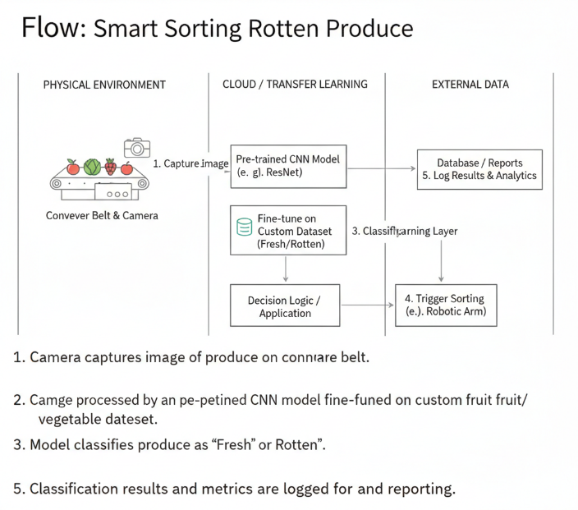

User Stories
Use the below template to list all the user stories for the product.
User Type | Functional Requirement (Epic) | User Story Number | User Story / Task | Acceptance Criteria | Priority | Release
Customer (Mobile User) | Registration | USN-1 | As a user, I can register for the Smart Sorting application by entering my email, password, and confirming my password to monitor my fruits and vegetables. | I can successfully create an account and access my dashboard. | High | Sprint-1
Customer (Mobile User) | Registration | USN-2 | As a user, I will receive a confirmation email after registering for the application. | I receive a confirmation email and can verify my account by clicking the confirmation link. | High | Sprint-1
Customer (Mobile User) | Login | USN-3 | As a user, I can log into the Smart Sorting application using my registered email and password. | I can log in successfully and access my personalized dashboard. | High | Sprint-1
Customer (Mobile User) | Produce Monitoring | USN-4 | As a user, I can capture or upload images of fruits and vegetables to check whether they are fresh or rotten. | The system analyzes the image and displays the classification result (Fresh/Rotten) with accuracy. | High | Sprint-1
Customer (Mobile User) | Alerts & Notifications | USN-5 | As a user, I receive real-time alerts when the system detects that stored produce is starting to rot. | I receive push notifications with item details and suggested action (consume soon/remove). | High | Sprint-2
Customer (Mobile User) | History Tracking | USN-6 | As a user, I can view the history of scanned fruits and vegetables with their status reports. | I can access a list showing date, image, and classification result. | Medium | Sprint-2
Customer (Web User – Supermarket/Plant Staff) | Bulk Scanning | USN-7 | As a supermarket or plant staff member, I can scan multiple fruits and vegetables in real-time using a camera system. | The system automatically classifies items and marks rotten ones for removal. | High | Sprint-1
Customer (Web User – Supermarket/Plant Staff) | Quality Report | USN-8 | As a staff member, I can generate quality control reports showing percentage of fresh vs rotten items. | The system generates downloadable reports with summary statistics. | Medium | Sprint-2
Customer Care Executive | Issue Management | USN-9 | As a customer care executive, I can view and respond to user complaints related to incorrect classification or technical issues. | I can track, update, and resolve user tickets from the admin panel. | Medium | Sprint-2
Administrator | User Management | USN-10 | As an administrator, I can manage user accounts including activation, deactivation, and role assignment. | I can successfully modify user status and roles in the system. | High | Sprint-1
Administrator | Model Management | USN-11 | As an administrator, I can update and deploy improved transfer learning models for better accuracy. | The new model can be uploaded, tested, and deployed without system failure. | High | Sprint-2
Administrator | Analytics & Monitoring | USN-12 | As an administrator, I can monitor system performance, accuracy metrics, and usage statistics. | I can view dashboards showing model accuracy, number of scans, and detection rates. | Medium | Sprint-2

